Advance Computer Network Assignment 1
Submitted by: Ankur Mishra
- Capture and analyze ICMP packets (Ping request and reply)
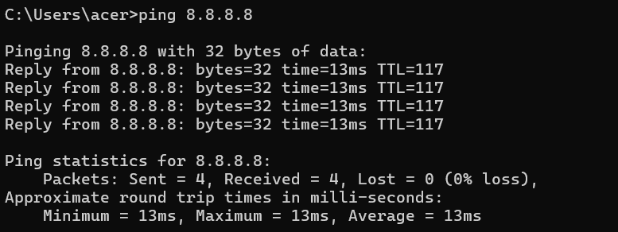
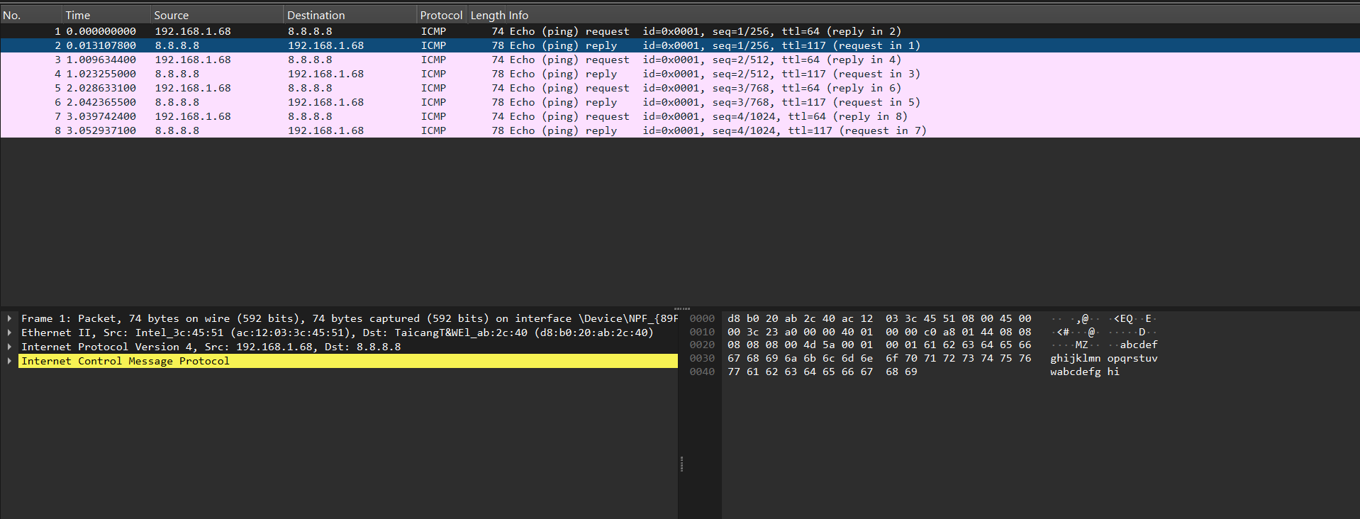
Protocol: ICMP
Source: 192.168.1.68
Destination: 8.8.8.8
Packet Length: 74 bytes

ICMP packets observed:
· Echo Request
· Echo Reply
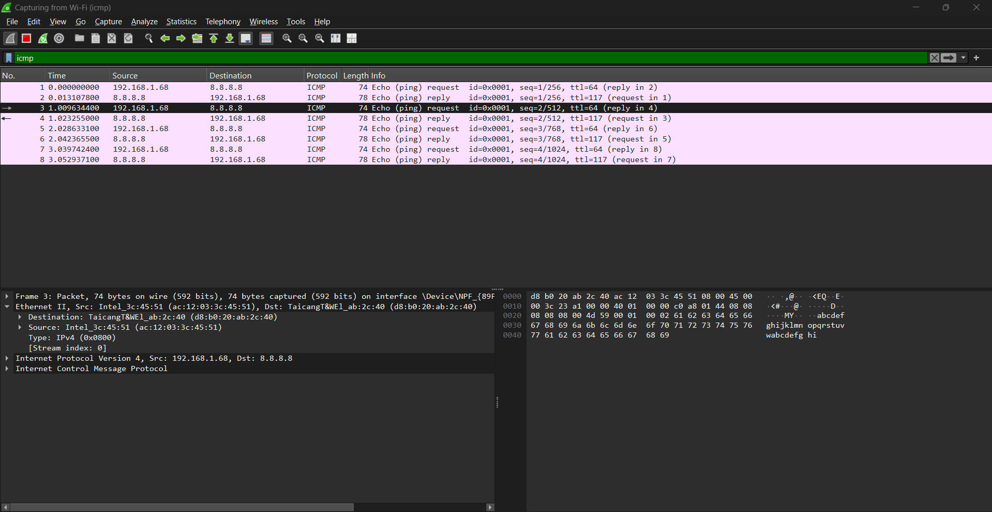
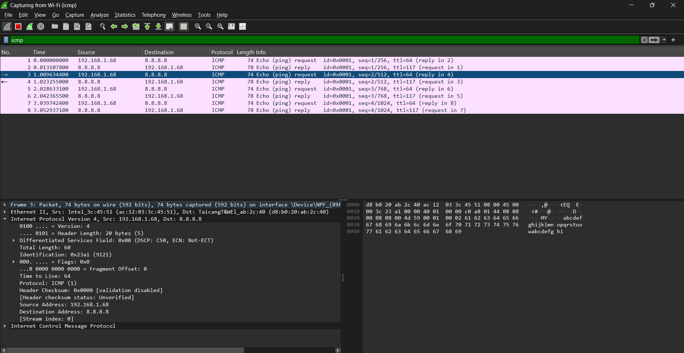

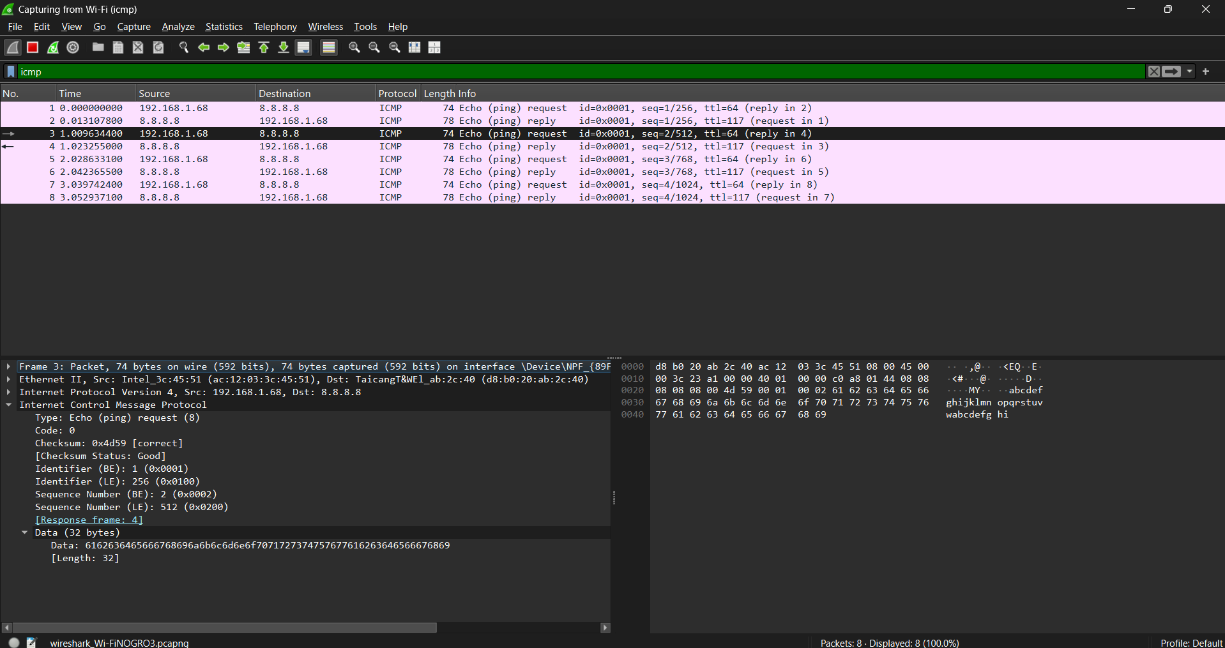
- Analyze TCP packets and observe the TCP three-way handshake

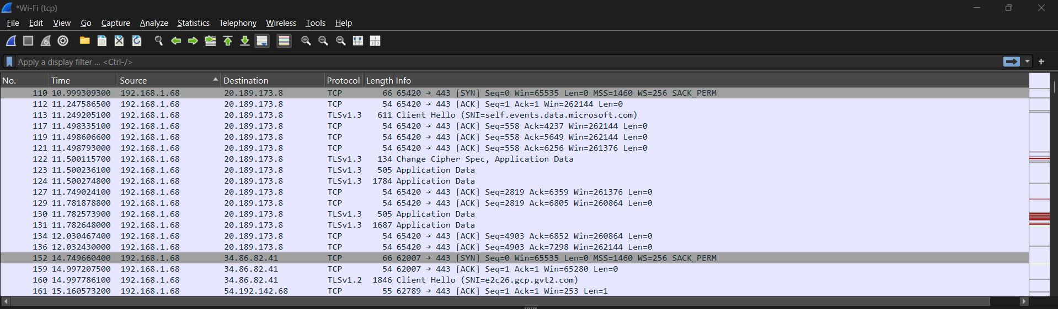
TCP Three-Way Handshake:
1. Client sends SYN to initiate connection.
2. Server replies SYN-ACK acknowledging request.
3. Client sends ACK and connection is established.
Source IP: 192.168.1.68
Destination IP: 20.189.173.8
Source Port: 65420
Destination Port: 80 (HTTP)
- Capture and analyze UDP packets
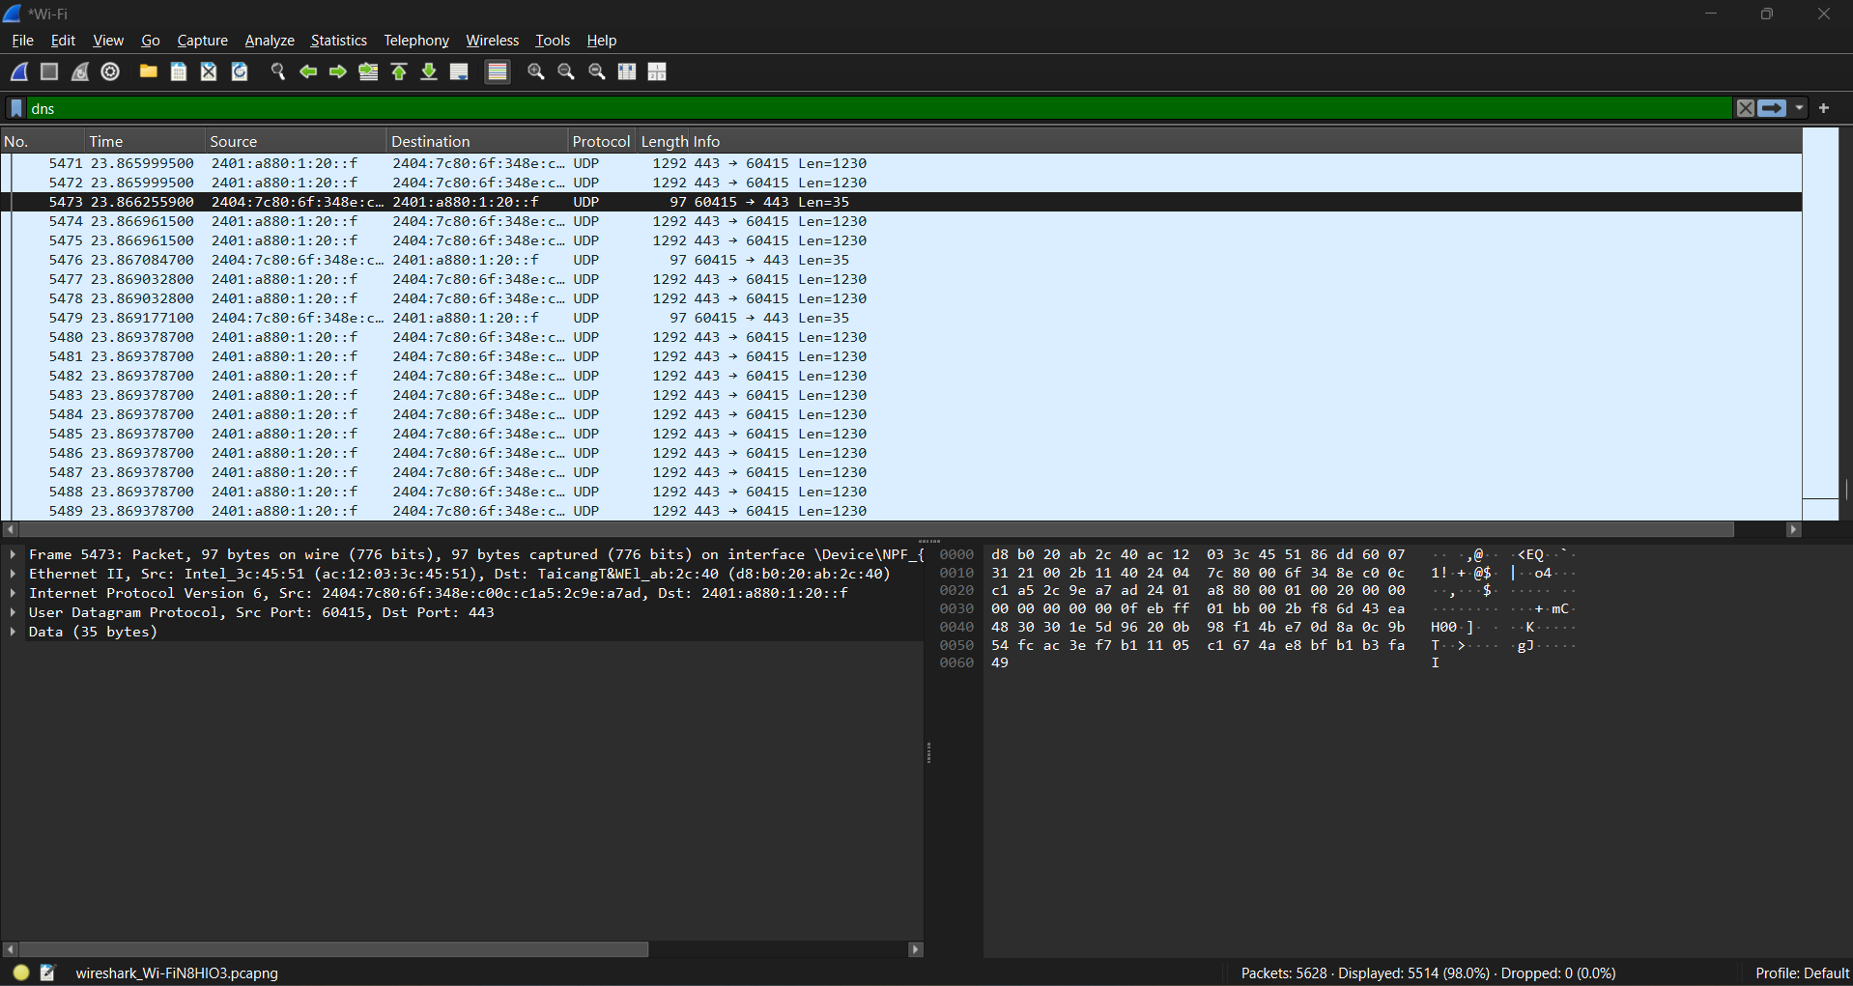

Protocol: UDP
Source Port: 60415
Destination Port: 443

- Capture and analyze DNS query and response packets
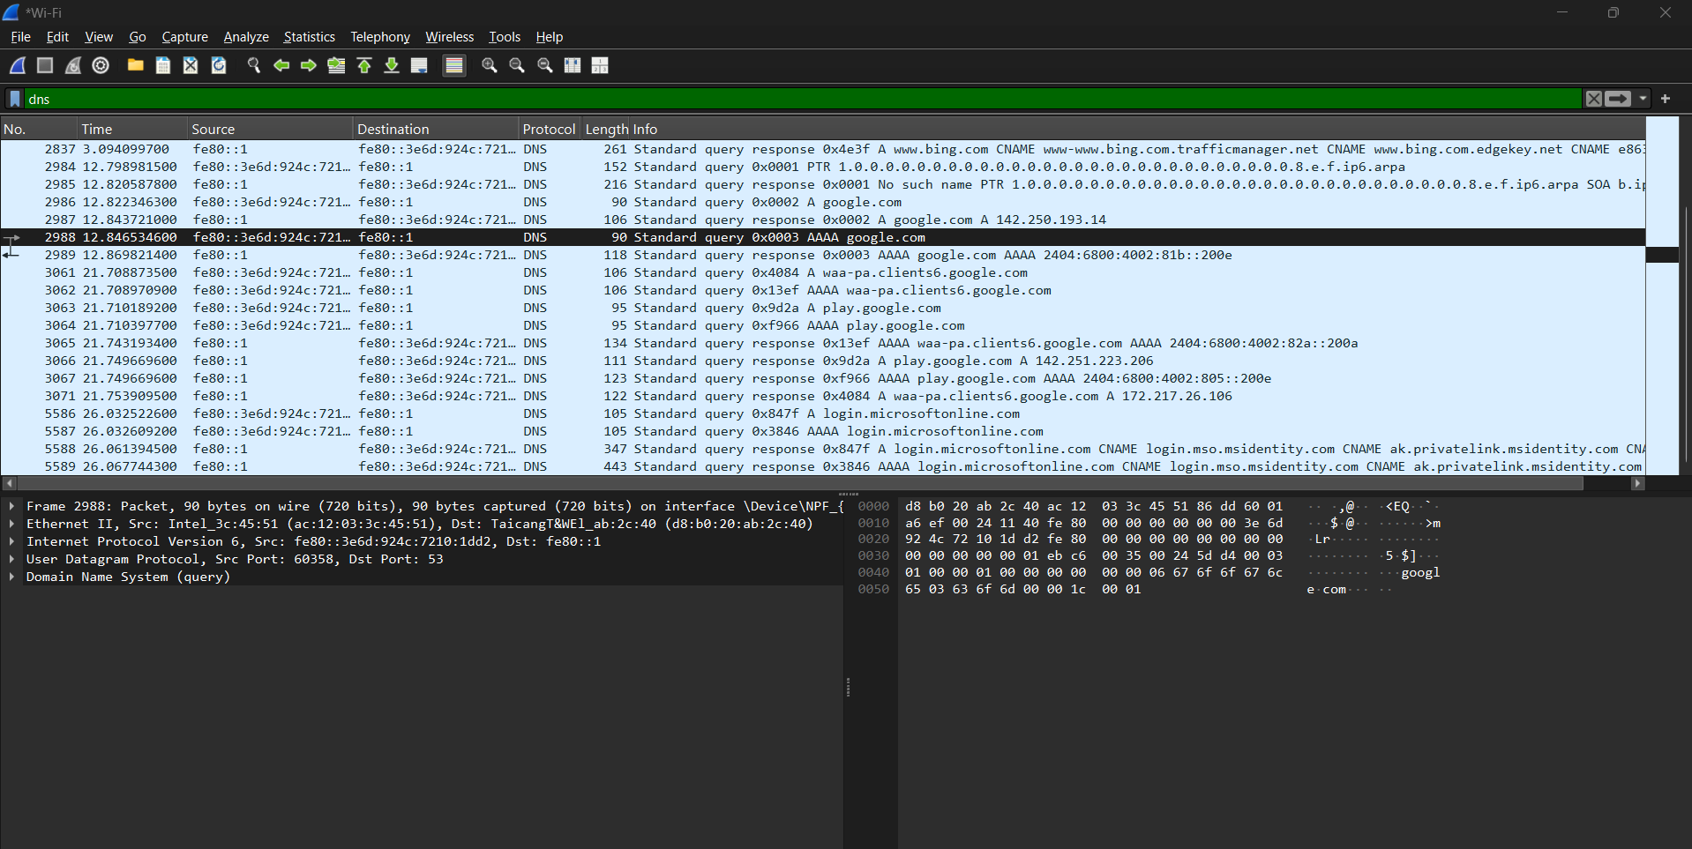
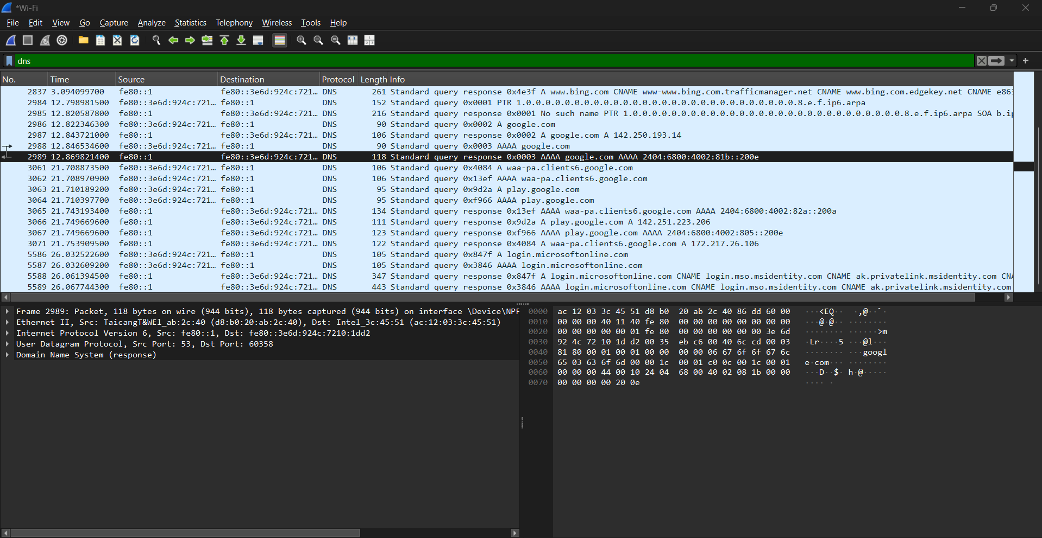

- Capture and analyze HTTP packets
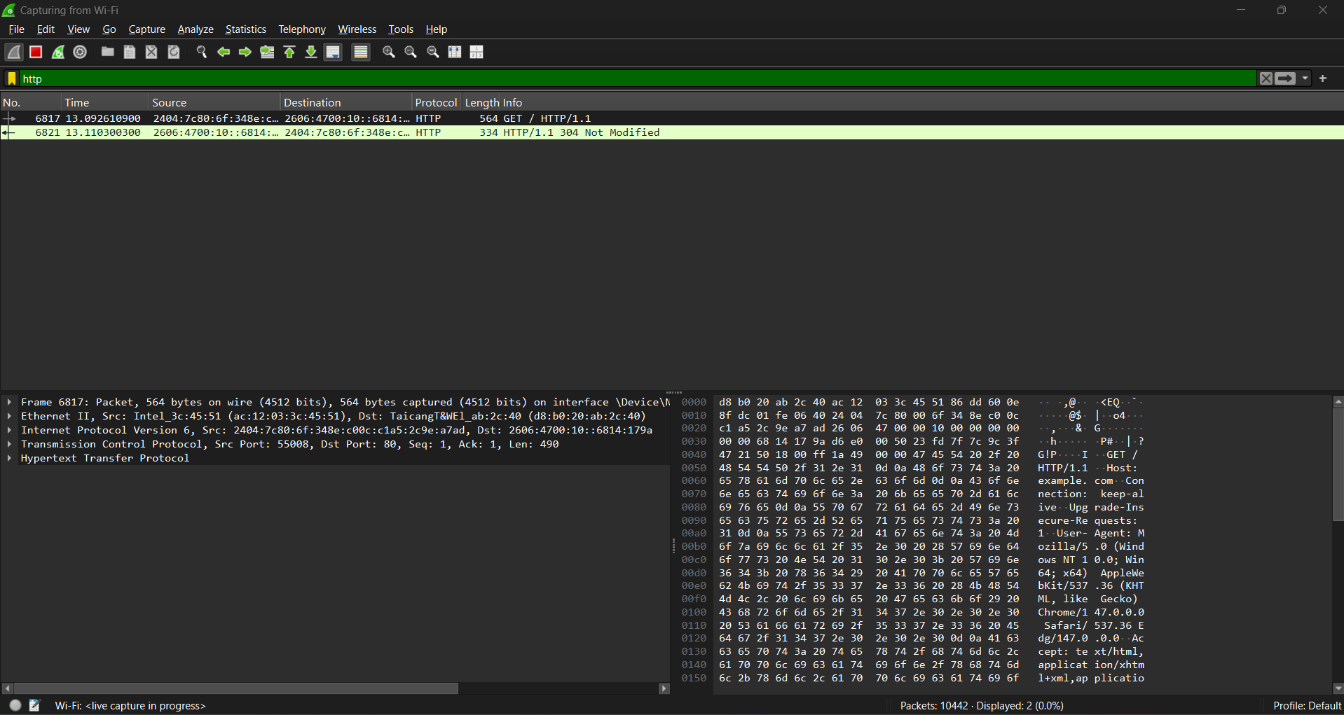

- Analyze ARP request and reply packets
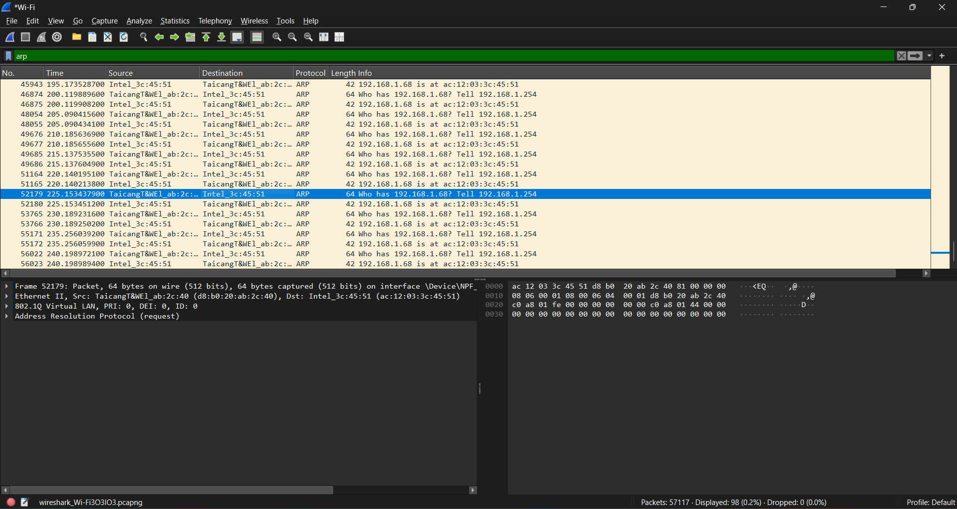
ARP Request
Sender asks: Who has 192.168.1.68?
ARP Reply
Response gives MAC mapping: 192.168.1.68 is at ac:12:03:3c:45:51

- Identify source and destination MAC and IP addresses in captured packets
MAC Addresses
- Destination MAC Address: d8:b0:20:ab:2c:40
- Source MAC Address: ac:12:03:3c:45:51
IP Addresses
- Source IP Address: fe80::1
- Destination IP Address: fe80::3e6d:924c:7210:1dd2

